Research and Grant Office

The British University in Dubai

Research Ethics Manual for Ethical Research at BUiD

Approved by the Research Committee and the Research Ethics Committee on November 2019
Policy cross document: 10.3 Ethics in research involving human subjects personal data, or confidential material
1. Introduction

1.1 This handbook outlines policy and provides guidance for the development and maintenance of appropriate ethical approaches to the conduct, supervision and utilisation of research. As such, it underpins, supplements and enhances the principles and operational requirements flowing from the need to work within professional codes of conduct and relevant legislation.

1.2 The word ‘research’ is used in an inclusive way to accommodate the range of activities that support original and innovative work in the whole range of academic, professional and technological fields, including humanities, traditional, performing, and other creative arts. It is not used in any limited or restricted sense, or relating solely to a traditional 'scientific method'. The University recognises that a number of professional practices and sectors have their own codes of ethics; these codes and the University’s Research Ethics requirements supplement each other and should be applied as necessary and fitting, both in professional and associated scholarly practices.

1.3 Research is generally understood as an enterprise invested with mutual respect and trust between researchers, participants, stakeholders, academic and public audiences. As such it is subject to ethical review to ensure that it is conducted in accordance with its responsibilities to individual participants and the wider public. Most particularly the ethical review of research is intended to:

- ensure that any foreseeable harm to the physical, psychological, social well-being, health, values and dignity of participants, researchers and other stakeholders is minimised;
- and that the rights of participants, researchers and other stakeholders are upheld, including participants’ right to informed consent, privacy, confidentiality and anonymity.

1.4 The research lifecycle includes the planning stage, the period of funding for the project and all activities that relate to the project once funding has ended. The research lifecycle also includes knowledge exchange and impact activities, the dissemination process and the archiving, future use, sharing and linking of data.

1.5 The ethical dimensions of research relate to issues of research integrity and as such involve more than these specific responsibilities to take account the interests of the public and the researchers to incorporate the credibility and standing of scholarly research. Some of these dimensions include:

- The collection, use, and interpretation of research data
- Methods for reporting and reviewing research plans or findings
- Relationships among researchers
- Relationships between researchers and those that will be affected by their research
- Means for responding to misunderstandings, disputes, or misconduct
- Options for promoting ethical conduct in research

1.6 The University’s Research Ethics Committee is responsible for reviewing applications for ethical approval. Any research project proposal aiming for endorsement or securing budget grants from the University cannot proceed to the Research Committee before it is cleared by the Research Ethics Committee. Similarly, any doctoral or masters proposal may not proceed to the empirical stage before being approved by Research Ethics Committee.
2. Principles and Expectations for Ethical Research

2.1 The primary responsibility for the conduct of ethical research lies with the researcher. It is a fundamental principle that staff and students engaged in research adopt a continuing personal commitment to act ethically, to encourage ethical behaviour in those with whom they collaborate, and to consult where appropriate concerning ethical issues.

2.2 There are six key principles of ethical research that are expect to be addressed:

- Research participants should take part voluntarily, free from any coercion or undue influence, and their rights, dignity and (when possible) autonomy should be respected and appropriately protected.
- Research should be worthwhile and provide value that far outweighs any risk or harm. Researchers should aim to maximise the benefit of the research and minimise potential risk of harm to participants and researchers. All potential risk and harm should be mitigated by robust precautions.
- Research staff and participants should be given appropriate information about the purpose, methods and intended uses of the research, what their participation in the research entails and what risks and benefits, if any, are involved.
- Individual research participant and group preferences regarding anonymity should be respected and participant requirements concerning the confidential nature of information and personal data should be respected.
- Research should be designed, reviewed and undertaken to ensure recognised standards of integrity are met, and quality and transparency are assured.
- The independence of research should be clear, and any conflicts of interest or partiality should be explicit.

2.3 To implement these principles:

- Responsibility for the conduct of University affiliated research by staff or students, in line with relevant ethics principles, rests with the Principal Investigator. However all co-researchers involved are expected to take personal responsibility for undertaking research to the highest ethical standards.
- Ensuring that research is subject to appropriate ethics review and monitoring lies with the Research Ethics Committee.
- The Research Ethics Committee have clear, transparent and effective procedures for ethics review and governance and appropriate mechanisms for monitoring.
- Research should be designed in such a way that the dignity and (when possible) the autonomy of research participants is respected and appropriately protected.
- Ethics review should always be proportionate to the potential risk. Where possible, risks should be minimised; for example, whether the research involves primary data collection or the re-use of existing data.
- Research involving primary data collection will always raise issues of ethics that must be addressed. Whilst the re-use of some datasets may be relatively uncontroversial and require only light-touch ethics review, novel use of existing data and especially data linkage, as well as some uses of administrative, internet-mediated data and controlled data, will raise ethics issues

3. Ethics Form and Protocols

3.1 A copy of the Research Ethics Form can be found at the end of the document. The same form can be filled by either doctoral/masters research students or by academic staff.

3.2Depending on the assessed level of risk of the research, the ethics form submitted to the Research Ethics Committee for review is to be expected to include some of the following information:

- Aims of the research and scientific background of the research.
- Study design.
- Participants – who (inclusion and exclusion criteria), how many, how potential participants are identified and recruited.
- Potentially vulnerable individuals or groups.
- Methods of data collection and analysis.
- Response to any conditions of use set by data custodians and data producers.
- Principal investigator’s summary of potential ethics issues and how they will be addressed. For projects that include non-academic or international collaborators, this summary should be agreed by all parties.
- Benefits to research participants or third parties and how this will be maximised.
- Risks to participants or third parties and what has been done to assess, obviate or minimise risks.
- Risks to researchers and in particular how researchers will be protected or supported.
- Procedures for freely given and adequately informed and valid consent – information provided and methods of documenting.
- Procedures for dealing with information arising in the course of fieldwork that is a cause for concern, such as disclosures from participants or behaviours or incidents observed that raise significant concerns about the safety or wellbeing of participants or other people.
- How any data collected will be kept secure, and methods of transferring data within teams.
- Mechanisms for managing data-sharing outside the proposed research team.
- Expected outcomes, impacts and benefits of research.
- Pathways to impact and dissemination (and feedback to participants where appropriate) and possible ethics implications of these plans.
- Data management and curation; what measures have been taken to ensure confidentiality, privacy and data protection during and beyond the end of the project?
- Potential conflicts of interests with researchers or participants.

*Information sources: University of Gloucestershire Research Ethics Handbook 2018 and ESRC Framework for Research Ethics 2015
4. Ethics Review Process

4.1 Doctoral/Masters Students:

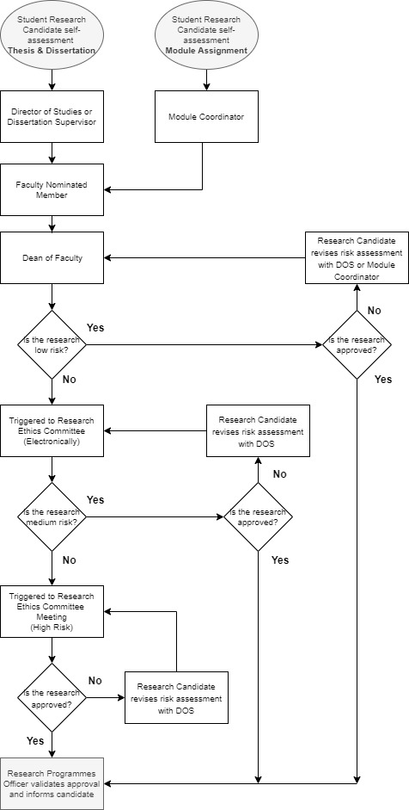
4.2 Academic Staff:

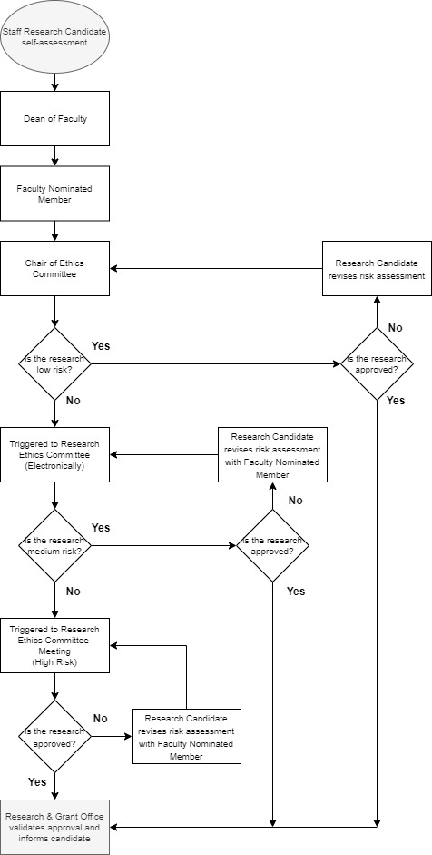
5. Frequently Asked Questions
(Source: ESRC Framework for Research Ethics 2015)

5.1 Can all risks be avoided?
Not all risks can, or in some cases should, be avoided, but it is important that researchers develop awareness of potential risks. Such risks may be difficult or impossible to quantify or anticipate in full prior to the start of a research project, especially in longitudinal, ethnographic research and research taking place in other countries. Nevertheless, researchers should endeavour to determine possible risks and their management (not least through the methodological strategy and instruments they adopt) prior to the start of a project, which may then require more formal ethics review.

5.2 How do you inform participants of potential risks?
Once potential risks have been identified, researchers should ensure that these are discussed with research participants in order to secure valid consent. When presented with sufficient information individuals will usually be able to use reasoned judgment to decide whether or not they wish to participate. There is also therefore the need to ensure that potential participants have the capacity to understand the consequences (and risks) of participating in order to give valid informed consent.

5.3What is informed consent?
Informed consent entails giving sufficient information about the research and ensuring that there is no explicit or implicit coercion so that prospective participants can make an informed and free decision on their possible involvement. Information should be provided in a form that is comprehensible and accessible to participants, typically in written form, and time should be allowed for the participants to consider their choices and to discuss their decision with others if appropriate. The consent forms should be signed off by the research participants to indicate consent. Where participants are in a potentially vulnerable or dependent position (eg children) it is important to ensure that they have the time and opportunity to access support in their decision-making, for example by discussing their choice with a trusted adult. Where consent is sought from children it is normally good practice to secure permission from a responsible adult in addition to child consent. Where participants are not literate verbal consent may be obtained, but this should wherever possible include a recorded written witness sign-off. Where consent is not to be secured, a full statement justifying this should be submitted to the Research Ethics Committee for review. In longitudinal research it may necessary to re-negotiate consent during the lifetime of the research.

5.4 Is it legitimate to expose some research participants/organisations to risk?
This might arise for two reasons. First, research may be deliberately and legitimately opposed to the interests of the research participants or organisations in cases where the objectives of the research are to reveal and critique fundamental economic, political or cultural disadvantage or exploitation. Much social science research has a critical role to play in exploring and questioning social, cultural and economic structures and processes (for example relating to patterns of power and social inequality, and institutional dynamics and regimes that disadvantage some social groups over others, intentionally or not). Such research results may have a negative impact on some of the research participants/organisations. Principles of justice should, however, mean that researchers would seek to minimise any personal harm to individuals. Secondly, researchers should also consider how to balance the potential of immediate or short-term risks to research participants against longer-term gains to future beneficiaries. It is the responsibility of the research proposers to make such a case in detail to the Research Ethics Committee. In making a decision, the Research Ethics Committee may wish to consider safety issues and whether participants should have the right of protection.
5.5 What happens when risks only become apparent later in the research?
All research can develop in ways that raise unforeseen ethics implications. Researchers should be able to identify ethical issues throughout the lifecycle of the research. Should an unanticipated ethics risk appear somewhere along the research lifecycle, Principle Investigators are required to report it to the Research Ethics Committee through the nominated ethics faculty member (for staff research projects) or the director of studies (for doctoral/masters students).

5.6What are the risks in disseminating findings?
The media can be very helpful in disseminating findings, but the possible impact on research participants, their families and organisations, and populations from which the sample is drawn needs to be thought through, particularly where anonymity may be jeopardised or where there is potential for stigmatisation of individuals or groups or of misuse or misrepresentations of research findings (eg to further political agendas). For example, descriptions of participants (eg in case studies) need to take care to ensure that they do not risk making those who take part identifiable, particularly if sample sizes are small or participants have distinctive characteristics that may make them recognisable.

5.7What does it mean that research participants should participate voluntarily, free from any coercion?
In all cases of research, researchers should inform participants of their right to refuse to participate or withdraw from the investigation whenever and for whatever reason they wish. There should be no coercion or undue influence of research participants to take part in the research. Research participants, however, may be given incentive (monetary or otherwise) for their time and expenses involved; for e.g. a free prize draw or book or gift vouchers to encourage survey responses. Incentives should not override the principles of freely given and fully informed consent. Participants should know before they start the research that they can withdraw from the study at any time without losing their incentives. Respondents should not be required to do anything other than agree to participate.

5.8Do participants have a right to withdraw consent?
In giving consent, participants have as mentioned above the right to withdraw consent as well as the right not to answer particular questions. All research should indicate the point at which data will have been anonymised and amalgamated and in certain circumstances cannot then be excluded. Some researchers give a date after which participants cannot withdraw consent or ask for data destruction. If data are to be archived and shared, participants need as far as possible to give specific consent. The researcher should take into account the long-term use, including the potential for data linkage and preservation of data when obtaining consent.

5.9What if it is not possible to obtain informed consent?
Informed consent may be impracticable or meaningless in some research, such as research on crowd behaviour, or may be contrary to the research design, as is sometimes the case in psychological experiments where fully informed consent would compromise the objective of the research. In some circumstances (such as when users of illegal drugs and illegal groups are involved) written consent might also create unnecessary risks for research participants. Even in this last case a researcher should seek informed consent where possible to secure the trust and confidence of those involved, but care must be taken to ensure than consent processes (eg asking for written signatures) do not pose risks to participants. Such circumstances may encourage the researcher to seek verbal consent from participants, which ensures they are capable of understanding the potential risks involved within the research. In some contexts consent may need to be managed at a point beyond the completion of research fieldwork, for example where covert observation is necessary and warranted.

Research ethics form self-assessment

Application for approval of research activity involving human subjects, personal data, or confidential material

This application form is to be used by researchers seeking approval from the Research Ethics Committee.

Research that involves human subjects, personal data, or confidential material, and is associated with The British University in Dubai, cannot begin until ethical approval has been obtained.

Section I is a general research identification table.

Section II is for the details of the ethical matters your research might involve and the necessary steps you are planning to take to address them.

Section III is an ethics checklist that will help you identify your research risk level. If you answer ‘Yes’ to any one of the high risk statements, then your research is High Risk. If you answer ‘Yes’ to any one of the medium risk statements, and ‘No’ to all high risk statements, then your research is Medium Risk. If you answer ‘No’ to all high risk and medium risk statements, then your research is Low Risk.

If you have documents related to the ethical considerations of the research such as, for example, a consent letter, evidence of external approval, questionnaire samples or interview questions, you can enclose them with this form before submission.

- Research identification

Name
Faculty/Programme
Contact number
Email
Research type | □ Research project □ Doctoral/Masters research □ Module assignment
Research title
Date
Submitted to (name) | □ Faculty nominated member (research projects):  □ Director of Studies (doctoral research):  □ Dissertation supervisor (Masters research):  □ Module coordinator (module assignment):

- Research ethics details

Background and rationale for study (this should be sufficient to justify the proposed research). Aims and objectives of the research (or the research question/s) and potential benefits of proposed research: 500 words max)
Main ethical consideration(s) of the research
(the ethical matters your research may involve)
Methods of data collection
(outline in detail how data will be collected and attach a copy of any questionnaires, interview schedules or observation guidelines to be used: 400 words max)
Recruitment of participants
(outline the number and type of participants involved; give details of how potential participants will be identified and invited to take part in the study; and how informed consent will be obtained: 300 words max)
Please attach a copy of your information sheet(s), draft materials such as interview questions etc. and consent form as well as indication of planned time of issue/use. If you are not using a consent form, please explain why.

□ Attached

Potential adverse effects on participants and steps to deal with them
(outline if you anticipate any potential harm or negative consequences including psychological stress, anxiety or upset which may be induced by the study, and the steps to be taken to address them)
Steps to be taken to ensure confidentiality of data
(outline steps to ensure confidentiality, privacy and anonymity of data during collection, storage and publication. Specifically identify any confidential or personal information, and/or any other party’s protected intellectual property which you need to use and safeguard)
Steps to be taken to ensure financial and commercial propriety
(specifically identify any external funding or significant third-party financial involvement with the research)
Other plans to address a particular ethical matter not mentioned above

- Research ethics checklist

If you answer ‘Yes’ to any one of the high risk statements, then your research is High Risk. If you answer ‘Yes’ to any one of the medium risk statements, and ‘No’ to all high risk statements, then your research is Medium Risk. If you answer ‘No’ to all high risk and medium risk statements, then your research is Low Risk.

High Risk
Will consent be coerced out of participants by those who would likely benefit from the research? | □Yes □No
Will it be necessary for participants to take part in the study without their knowledge and consent at the time? | □Yes □No
Will the study involve some form of invasion of privacy? | □Yes □No
Is discomfort or harmful impact to participants likely to result from the study? | □Yes □No
Is there a possibility that the safety of the researcher may be in question? | □Yes □No
Will the research require the researcher to be deceptive or dishonest with the participants? | □Yes □No
Will financial inducements (other than reasonable expenses and compensation for time) be offered to participants? | □Yes □No
Will the research have negative intrusive physical or psychological effects on the participants? | □Yes □No
Will the names of the participants or the institution appear in the research? | □Yes □No
Does the research involve the condition of destroying recorded data after it is used? | □Yes □No
Medium Risk
Will the research involve governmental institutions or participants such as, for example, the military or the judiciary? | □Yes □No
Will the study involve discussion of sensitive or potentially sensitive topics and issues? | □Yes □No
Does the research involve potentially vulnerable participants (for example children, prisoners, or people with disabilities)? | □Yes □No
Does the research involve participants that are unable to give consent? | □Yes □No
Will the research involve administrative or secure data that requires permission from the appropriate authorities before use? | □Yes □No
Will research involve the sharing of data or confidential information beyond the initial consent given? | □Yes □No

Risk level identified | □ Low □ Medium □ High

The researcher undertakes not to deviate from the original consent granted by the University’s Research Ethics Committee. The researcher bears full and sole responsibility for any deviation from this consent and all consequences arising from such deviation. The researcher waives all right of appeal in the event of any penalties applied by the University arising from such deviation.

Declaration by the Researcher:

Having read the University’s Research Policy I declare that the information contained herein is to the best of my knowledge and belief accurate.

I am satisfied that I have attempted to identify all risks that may arise in conducting this research and acknowledge my obligations as researcher and the rights of participants. I am satisfied that all researchers (including myself) working on the project have the appropriate qualifications, experience and facilities to conduct the research set out in the attached document and that I, as the lead researcher, take full responsibility for the ethical conduct of the research in accordance with subject-specific and University Ethical Guidelines (Policies and Procedures Manual), as well as any other condition laid down by the Research Ethics Committee. I am fully aware of the timelines and content for participants’ information and consent.

Name: ___________________________________

Signature: _____________________________________ Date: _________________________

FOR OFFICE USE ONLY
LOW RISK RESEARCH

Staff
Chair of Ethics Committee

Name:

□ Approved
□ Not approved

Signature: | Date:

Students
Dean of Faculty

Name:

□ Approved
□ Not approved

Signature: | Date:

Authorisation for conducting research (only if approval is obtained):

The Committee has confirmed that this project fits within the University’s Policies for Research and I authorise the low risk research proposal on behalf of BUiD’s Research Ethics Committee.

Name: __________________________

Signature: ___________________________________ Date: __________________________

(Chair of the Research Ethics Committee)

FOR OFFICE USE ONLY
MEDIUM RISK RESEARCH

Staff and Students
Endorsement by the Faculty’s Research Ethics Committee member after electronic referral to all Research Ethics Committee members

Name:

□ Approved
□ Not approved

Signature: | Date:

Authorisation for conducting research (only if approval is obtained):

The Committee has confirmed that this project fits within the University’s Policies for Research and I authorise the medium risk proposal on behalf of BUiD’s Research Ethics Committee.

Name: __________________________

Signature: ___________________________________ Date: __________________________

(Chair of the Research Ethics Committee)

FOR OFFICE USE ONLY
HIGH RISK RESEARCH

Staff and Students
Endorsement by the Faculty’s Research Ethics Committee member after meeting of Research Ethics Committee members

Name:

□ Approved
□ Not approved

Signature: | Date:

Authorisation for conducting research (only if approval is obtained):

The Committee has confirmed that this project fits within the University’s Policies for Research and I authorise the high risk proposal on behalf of BUiD’s Research Ethics Committee.

Name: __________________________

Signature: ___________________________________ Date: __________________________

(Chair of the Research Ethics Committee)

